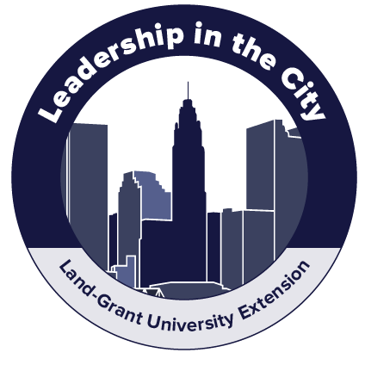

Dear [insert name here],
To help us move forward with the innovation and integration of our urban Extension efforts, I would like to participate in Leadership in the City course. The course is a 6-module online program spread over six months and is offered by Ohio State University Extension and University of Florida/IFAS Extension.
I have reviewed the agenda for this professional development program and feel the return on investment would be a major benefit as the content aligns directly to the priorities of our Extension work. [list priorities if you would like]
It’s a great value for this education offering geared specifically to urban Extension. During the 6-month program,
I will be able to:
- Learn from experienced leaders.
- Apply what I learn to our city, region, and state.
- Engage in critical thinking and creative problem solving.
- Participate in online collaborative learning.
- Meet peers from across the country.
- Develop a plan and portfolio of resources to improve my leadership ability and community conditions.
The agenda includes sessions on leadership, networks, inclusive engagement, marketing, innovation, and management. The complete agenda and details can be found at go.osu.edu/urbanleadership. Staff members in our organization will also benefit as I will meet with them when I complete the course to share and discuss potential opportunities for our community.
I am seeking approval for the online program expenses. The registration fee is $500.
Please accept this request to attend as I’m confident in the significant return we will receive for the small investment.
Thank you for your consideration.
[Your standard close]

